Activity: What is Happiness?
1.Ask pupils to take a moment to think about what happiness means to them. They should note down whatever comes to their mind.
Discuss pupils’ thoughts as a class and read out the happiness definition below:
Happiness is the state of being happy – in other words, being content or pleased with your life, your situation, or the person that you are. It means having good feelings about the present, (and maybe the past or the future), and feeling that you are able to achieve what you want, or able to enjoy yourself.

2.Pupils should now think about specific things that often make them happy. These could be activities, people, places or anything else that comes to their mind.
Discuss pupils’ thoughts as a class.

3. You may wish to prompt some debate by asking the question ‘can money buy happiness?’
Although happiness can be defined in general terms, it can also vary greatly from person to person, in terms of what brings them happiness. For example, for some people, happiness would be having a nice house, lots of money, or a really expensive car. These are all examples of material happiness – in other words, happiness that comes from possessing physical things. For other people, happiness would be being really popular, or having great friends. These are all examples of emotional happiness, which comes from the relationships that a person is able to form. Yet again, for other people, happiness might mean doing really well at school, getting high grades, becoming a master at their particular hobby or interest, and getting a top job in their chosen field. This might be classed as professional happiness, because it's focused on achieving potential. For other people, happiness might mean seeing everybody in society doing well and being looked after. We might call this social happiness, as it's focused on the wellbeing of other people. Of course, there are many more types of happiness, and many people have a mix of all of these.

Activity: How to increase your happiness
One-way scientists have discovered that can increase people’s happiness is by only doing things which enrich their life. Explain that the things we do on a daily basis can be split into three categories: Things which enrich us, for example reading, cooking. Things which do not enrich us, for example tidying, and things that are neutral but necessary, for example sleeping, eating. The simple fact is that if we do more things that enrich our lives than don’t, then we will feel happier!
Issue pupils with Worksheet 1: My Normal Day, to complete. Then ask pupils to discuss with a partner how they can reduce the ‘doesn’t enrich’ column and increase the ‘does enrich’ column.

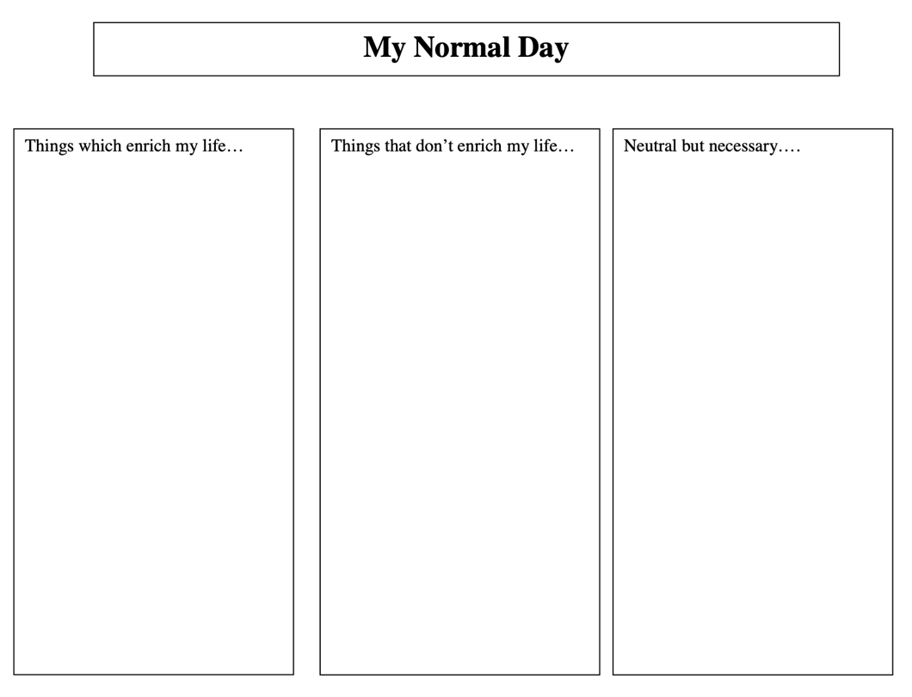
Worksheet 1: My Normal Day

